How to Use the OSLIS Video Quizzes
The OSLIS Committee developed a quiz for each Learn to Research video tutorial. You can use each quiz as a pre-test to assess prior knowledge, as a post-test to assess learning, or both. If you are using a quiz as a post-test, you may want to assign the quiz soon after watching the related video or after providing additional instruction on the topic.

Get Started – Make a Copy & Name the File
After you click on the Google Forms link on the OSLIS page, you will be prompted to make a copy of the quiz. Making a copy preserves the original and enables you to change the quiz and its settings to meet your needs.
The file name of the copied quiz will start with “Copy of.” You may want to rename that. You also may want to include “Pre-test” or “Post-test” (no quotes) in the file name if you plan to use the quiz for both purposes.

Use a Quiz as a Post-Test
Each quiz is set up to use as a post-test. That means students will be able to see their score and the correct answers immediately after taking the quiz. You may want to adjust the settings based on your preferences and situation. Click on the cog wheel () near the top of the quiz to get to the Settings section. To use a quiz as a pre-test instead, see the “Use a Quiz as a Pre-Test” section below.

Settings under the General Tab (Post-Test)
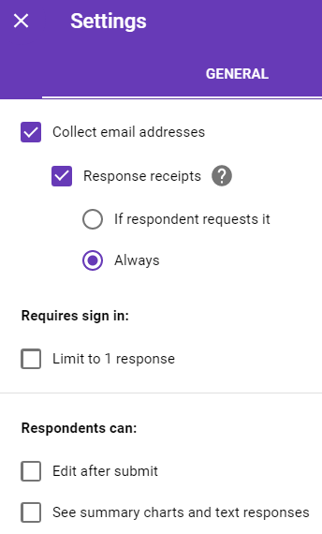
The screenshot shows the current settings in the General tab.
Collect Email Addresses: Collecting email addresses allows you to send a response to students. If you would rather collect students’ names instead of email addresses, simply uncheck “Collect email addresses,” and click on “Save.” Then, use the plus button () on the quiz page to add two short answer questions at the top so you can identify students by name instead of by email address: Last Name and First Name.
Response Receipts: With this checked, students will receive an email that shows the quiz questions and the answers they chose. The email will have a “View Score” link that leads to a Google page that shows the correct answers and the quiz score.
Requires Sign In: Since the “Limit 1 response” box is not checked, students will be able to take the quiz multiple times. To limit students to submitting only 1 response per quiz, check the “Limit to 1 response” box. That setting requires students to be signed in to a Google account.
Respondents Can: The current settings do not allow students to edit their answers after submitting the quiz or to see the summary charts and text responses of the other students in the class. Check one or both boxes if you want to change those settings.

Settings under the Presentation Tab (Post-Test)
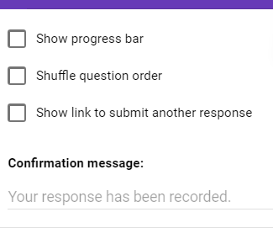
Show Progress Bar: Showing progress is not necessary since each quiz is only one page with no more than 10 questions.
Shuffle Question Order: If you decide to shuffle the question order, you may want to remove the question numbers on the quiz. Otherwise, the numbers will appear out of order when students take the quiz.
Correct Answers Tip: As the teacher or library staff, you may want to view the correct answer/s to a question. To do that, open your copy of the quiz, click on a question, and then click on “Answer key.” An answer key is also included on the educator version of the OSLIS video page.
Show Link to Submit Another Response: For the purposes of this quiz, this is unnecessary.
Confirmation Message: Google’s default confirmation message will display. You are welcome to change it.
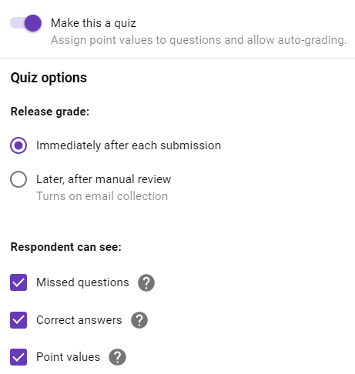
Settings under the Quizzes Tab (Post-Test)
Make This a Quiz: Each quiz has between 8 and 10 questions and is set to equal 100 points. If there are 10 questions, each is worth 10 points. If there are fewer questions, the point values vary based on the number of correct answers per question. To alter point values, click on a quiz question, and click on “Answer Key.” Pay attention to the “Total points” at the top of the quiz.
Release Grade: Since all of the questions are multiple choice, the score is set to be released immediately after a student submits a quiz. After students click on “Submit,” they will see an option to “View Score.”
Respondent Can See: The current settings allow students to see which questions they missed, the correct answers,
and the point values for each question.
Grading Tip for the “Later, After Manual Review” Setting: Choosing “Later, after manual review” allows you to edit grades before sending them to students. Students will have the option to have responses emailed to them, but there will not be a “View Score” option. There may be reasons to choose the “Later” setting. For example, Google Forms does not give partial credit, but you may want to assign partial credit to questions that have more than one correct answer. Or, you may want to add a short or long answer question, or change a multiple choice question into one.
To manually review student responses and scores, click on the “Responses” tab at the top of the Google Forms (quiz) page, click on “Individual,” and advance through the quizzes. To change the points awarded for a specific question, change the number in the area to the right of the question, and click on “Save.” Then click “Release Score” individually for each student. Or, to release scores for all students at once, click on “Summary” near the top of the page, scroll to the “Scores” section, and click on “Release Scores.”
Scores will be emailed to students, but students will not be able to see how they did on each question. Note: If you added the quiz to Google Classroom, students may be able to see more than their score.
For more information about gathering student responses, see the “Collect Responses” section below.
Save: Be sure to save any changes you made in the settings.
Take the Quiz Tip: Take the quiz before you assign it to students in order to see what information you receive about the test, especially if you leave “Collect email addresses” and “Response receipts” checked in the settings.

Use a Quiz as a Pre-Test
Again, if you plan to give both a pre-test and a post-test, make a separate copy of the quiz for each purpose. Add “Pre-test” to the file name of one and “Post-test” to the other (no quotes).
To use an OSLIS video quiz as a pre-test, you will likely want to change some settings. However, if you only plan to use the pre-test to determine what your students currently know about the topic – to determine where to concentrate your instruction – then you may not need to change the quiz settings since you will not use the same quiz again as a post-test.

Recommended Setting Changes for a Pre-Test
Collect Email Addresses / Response Receipts (under General Tab): Uncheck “Response receipts” to prevent students from receiving an email that lists the quiz questions and the answers that they chose. Note: That email would not show which answers are correct.
Release Grade (under Quizzes Tab): Since this is a pre-test, and because a post-test will follow, do not release grades immediately after students submit the quiz. Instead, change the “Release grade” setting to “Later, after manual review.” Then you can decide when or if to release the pre-test scores.
Respondent Can See (under Quizzes Tab): Choosing “Later, after manual review” overrides the “Respondent can see” settings. Once grades are released, students will only be able to see their score. They will not be able to see which answers are correct.
How to Change or Release Scores: To learn how to change scores or to email scores to students, see the information in the “Grading Tip” section at the top of this page.
Pre- vs. Post-Test Tip: If you plan to release pre-test grades immediately to the students – instead of using the “Later after manual review” option – AND you plan to use the same quiz as a post-test later, remember that students will have seen the questions and correct answers from their pre-test.
Save: Be sure to save any changes you made in the settings.

Share the Quiz Link (Pre-Tests & Post-Tests)
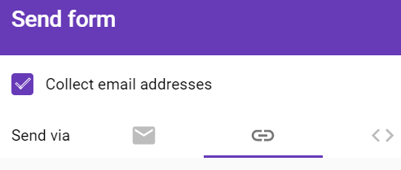
Send: Once you have reviewed or changed quiz settings, click on “Send” at the top right of the quiz page to open the “Send form.”
Link: Click on the link icon, and copy the link that appears. Share that link with students, or paste it into online assignments or your learning management system, like Google Classroom.

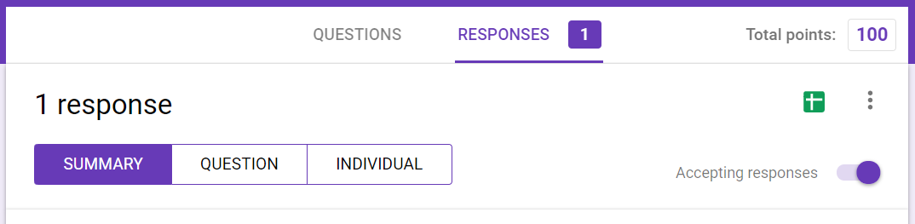
Collect Responses (Pre-Tests & Post-Tests)
Responses Tab: Once your students take a quiz, you can view the results and release the grades (if you chose to manually release grades at a later time) under the “Responses” tab.
Choosing “Release Scores” gives you the option to email quiz scores to students. That only applies if you changed the OSLIS grading default to “Later, after manual review” under the “Quizzes” tab.
Accepting Responses: Quizzes are set to accept responses by default. You can choose to turn this off when the period of time that students are allowed to take the quiz has passed – before releasing grades, for example.
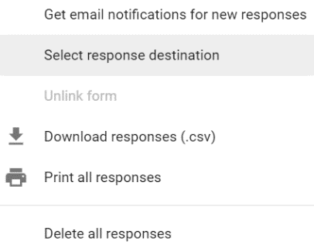
Create Spreadsheet: Click on the “Create spreadsheet” green icon and then on “Create a new spreadsheet” if you want to collect student responses in a Google spreadsheet. The responses spreadsheet will be created in the same folder that the Google Forms quiz is in.
More Menu: Click on the three vertical dots to open a menu with options to print quiz results, to download the responses as a spreadsheet, and to receive email notifications for new quiz responses.

Help
G Suite Learning Center: Get Started with Forms Quizzes
Tips for Using Forms Quizzes with Classroom

