Using a Library Database (Video)

Check your knowledge about this topic by answering these questions.
1. Library databases collect information, including articles and images, from which of the following sources? Mark all that are correct.
14 points
- Audio and video recordings
- Magazines and newspapers
- Reference books
- Weather forecasts and up-to-the-minute news

2. The text of an article that appears in a library database is ________________ the article that appeared in the original source.
12 points
- Different than
- The same as
- More credible than
- A summary of

3. Which statements are TRUE about library database articles and Internet articles? Mark all that are correct.
13 points
- It takes time for library database editors to review and upload articles.
- Articles that are in both a library database and on the Internet are posted at the same time.
- All website articles have been reviewed by editors or experts before being posted.
- Internet articles can be posted as events are happening.
4. Sometimes using information found in a library database is a better option for your school project than using information found on the Internet. Which statement about library databases is FALSE?
12 points
- Every library database covers all topics, so you will always find the information you need when using a database.
- Articles that are included in library databases have been evaluated by professionals for quality and accuracy.
- Some library databases only include content that is appropriate for specific age groups, like elementary students.
- Library databases often provide information that is not available on the free, open Internet.

5. Why do companies charge libraries and schools to use their library databases? Mark all that are correct.
13 points
- Actually, library database companies do not charge schools and libraries to use their databases.
- The library database companies have to pay their employees to select and add the information to the databases.
- The original publishers of the articles and images charge the library database companies money to use their content.
- The library database companies know that teachers require information from databases, so they charge for it.

6. There are several options to find information in a library database. The image below shows an example of which option?
12 points
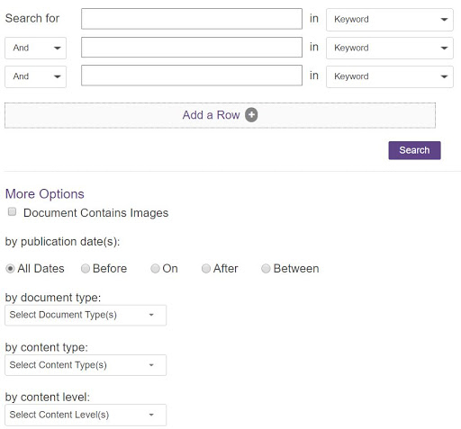

- Advanced search
- Browse
- Google search
- Search
7. Your teacher asked you to select a famous person for a biography research project. You do not know which person to choose, so you would like to get some ideas before you decide. Which library database option should you select in this situation?
12 points
- Advanced search
- Browse
- Google search
- Search
8. Which statement about library database search results is FALSE?
12 points
- Library databases often divide search results into categories based on the type of source.
- You can limit library database search results to only articles from a specific magazine or newspaper.
- You can limit library database search results to only articles with specific dates or reading levels.
- You can limit database search results to only articles that you will like.

